
Sultanate of Oman
Ministry of Agriculture, Fisheries & Water Resources
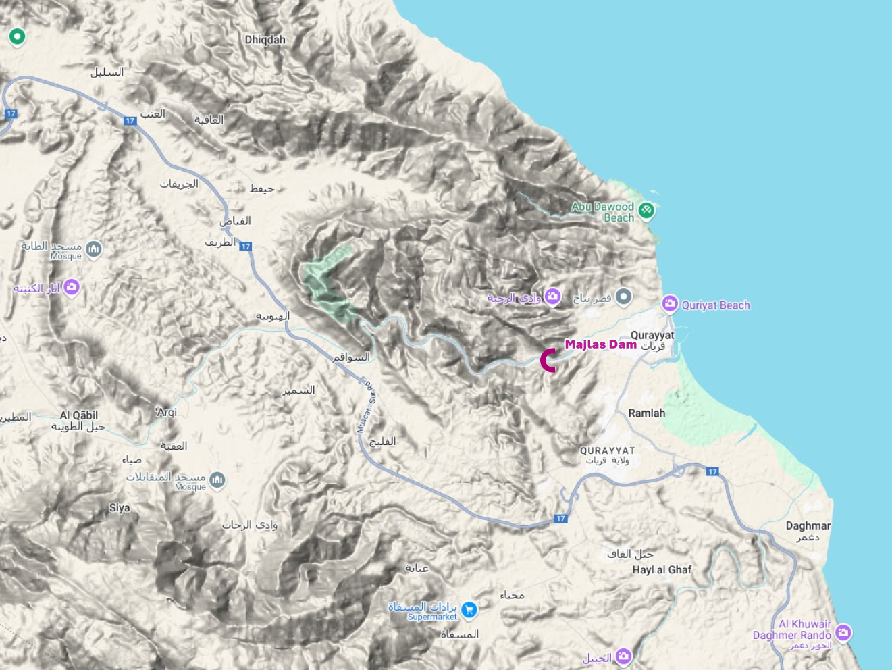
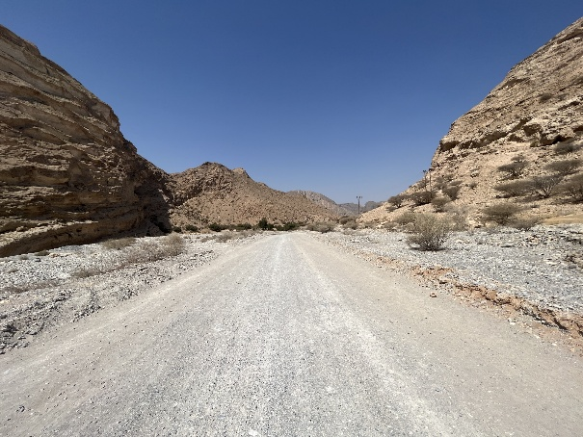
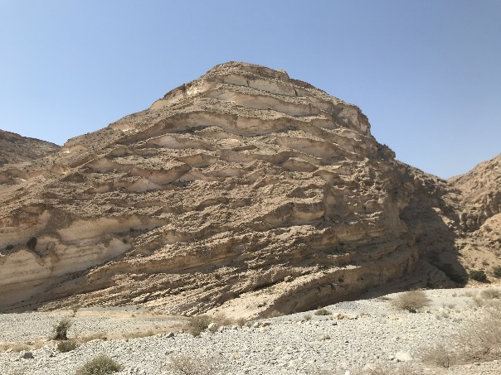
Consultancy Services for Design Review and Supervision of
Wadi Majlas Dam in Wilayat Qurayat, Muscat Governorate

Wadi Majlas Flood Protection Dam
Hydrology Report
Rev 00
July 2026



Table of contents
Executive Summary 5
Project Context 5
Scope of Work 5
Hydrological Approach 5
Hydraulic Design Methodology 5
Key Findings 6
Conclusions and Recommendations 6
Hydraulic Design of Channels– Block 6 7
1.1. Hydrology 10
1.2. Channel alignments 14
1.3. Channel condition and conflicts 17
1.4. Rainfall runoff simulation 19
1.4.1. Dams’ information 23
1.4.2. Dams’ elevation-volume-area curves 24
1.5. Hydraulic 31
1.5.1. Channel Design Criteria 31
1.5.2. Main issues in channel design 34
1.5.3. Channel depth 35
1.5.4. Channels design 36
1.6. Outfalls 49
1.7. Culvert/Bridge 51
1.8. Dykes 64
1.9. Conclusion 66

List of Tables
Table 1- Channel Design Process – Block 6 7
Table 2- Design Rainfalls 10
Table 3- Area reduction factor (ARF) 12
Table 4- Dams’ information 24
Table 5- Dams’ elevation-volume-area curves 25
Table 6- Dams’ Peak flow for different return periods 27
Table 7- Channel Design Criteria 31
Table 8- Mean tidal levels in North and South Al Batinah (m) from Oman Maritime Book 2024 32
Table 9- Challenges in design of channels 34
Table 10- Channels and dykes length in Block 06 36
Table 11- Channel sizes inventory 38
Table 12- Channel characteristics 42
Table 13- Number of cross drainage structures by type 51
Table 14- cross drainage structures detail 51
Table 15- Existing cross drainage structures’ photos 55
Table 16- Dykes characteristics 64

Table of Figures
Figure 1- Channel Design Process – Block 6 9
Figure 2-PMP grid 11
Figure 3- Rainfall Distribution Patterns 12
Figure 4 – Aea Reduction Factor Curve 13
Figure 5- Curve Number grid 14
Figure 6 – Channel Category Classification – Block 6 15
Figure 7- Channel alignments to control flood 16
Figure 8- Channel and dyke routes 17
Figure 9- Roads and utilities 18
Figure 10- Land use 19
Figure 11- Intermediate catchments with no upstream dam 21
Figure 12- HEC-HMS model for block 06 23
Figure 13- (a) Q200 (m³/s) 26
Figure 14- (b) Q200 (m³/s) 27
Figure 15- inflow and outflow hydrographs for all dams 30
Figure 16-OQ pipeline and Highway constraints 32
Figure 17- Channel in fill condition 33
Figure 18- Channel in cut condition 33
Figure 19- Existing wadi vs Design channel depth 35
Figure 20- Channel width 36
Figure 21- Channels and Dykes Summary (Total 383 km) 37
Figure 22- Channel Width Distribution 39
Figure 23- Channels’ name 40
Figure 24- Channels’ piecewise label 41
Figure 25- 3D view of implemented channels 49
Figure 26- Outfalls in the channel system 50
Figure 27- cross drainage structures 54
Figure 28- Dykes Height 65

Executive Summary

Hydraulic Design of Channels– Block 6
The study area encompasses two governorates in Northern Oman: North and South Al Batinah. The Ministry of Agriculture, Fisheries Wealth and Water Resources (MAFWR) commissioned Renardet S.A. & Partners Consulting Engineers L.L.C. in joint venture with Artelia Muscat to undertake this consultancy.
The full project title is: “Consultancy Services for Study and Prepare Comprehensive Master Plan for Flood Protection Dams, River Training Schemes and Updating of Flood Maps and Stormwater Drainage System in North and South Al Batinah Governorates, Sultanate of Oman.” The project encompasses dams, dykes, and stormwater channels designed to safeguard urbanised areas, industrial zones, critical infrastructure, and future developments from flood damage.
This report documents the hydraulic design of flood protection and stormwater channels for Block 6. All channels are designed with the upstream dams fully in place, as these dams play a critical role in attenuating peak inflows. The target design is the 200-year return period flood. Attenuated and routed dam outflows are conveyed through the channel network to reach the sea, providing an integrated flood protection system. Dyke heights are determined from HEC-RAS 2D hydrodynamic simulations. The channel design process follows a systematic, multi-step methodology as summarised in table below and following chart.
Table 1- Channel Design Process – Block 6
Stage | Title | Key Components / Methods
1 | Project Input | - Design Rainfall  - Topography  - Land Use  - Dam Characteristics (height, reservoir, spillway/outlet)
2 | Catchment Analysis | - HEC-HMS Subbasin Delineation  - Area Reduction Factor (ARF)  - SCS CN  - Time of Concentration (T_{C})  - Reservoir and Reach Routing parameters  - Diversions
3 | Rainfall–Runoff Simulation (HEC-HMS) | - 200-yr Peak Flow (and other return periods)  - Inflow/Outflow Hydrographs
4 | Channel Alignment | - HEC-RAS 2D results  - Wadi Geometry to adjust the channel dimension  - Site Visit  - Client/Authority Input
5 | Hydraulic Channel Design (SewerGEMS) | - Manning's Eq  - Depth  - Slope  - Velocity  - Freeboard  - Culvert Sizing  - Constraints (OQ pipeline, Bridge\Culvert)
6 | Performance Assessment (HEC-RAS) | - Dyke Heights  - Culvert\Bridge capacity assessment  - Outfalls  - System Verification  - 200-yr Protection Check
7 | Outputs | - Channel Dimensions  - Dyke heights  - Culvert\Bridge capacity  - Solution for bottleneck (outfalls, narrow channels)

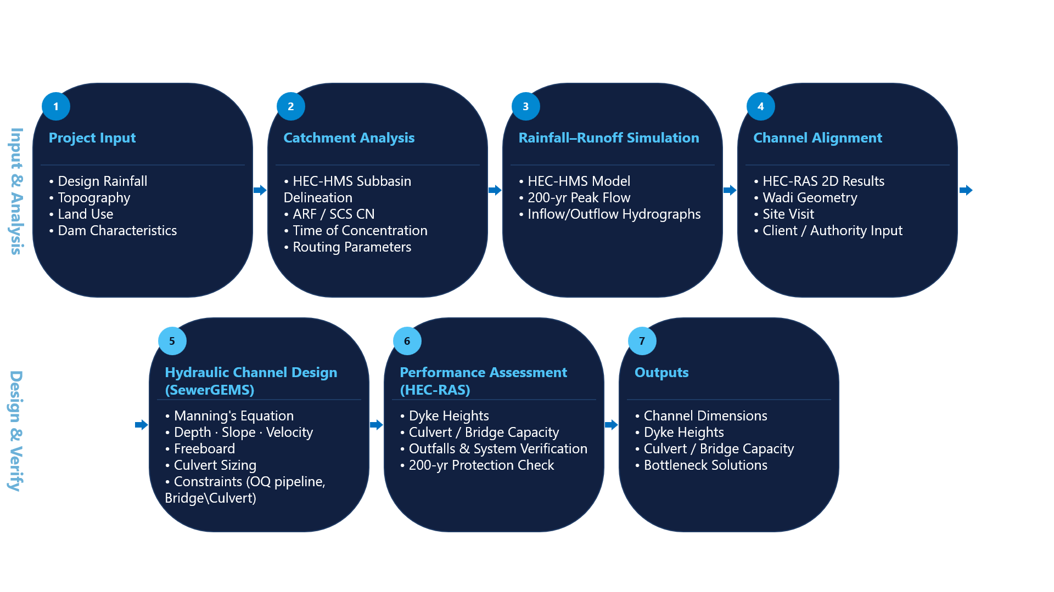
Figure 1- Channel Design Process – Block 6

Hydrology
A comprehensive, nationwide hydrology analysis is conducted by MAFWR recently. This study includes all the rainfall stations analysis, data cleaning, trend and outlier tests, gap filling, distribution fitting and eventually Regional Frequency Analysis (RFA) to calculate rainfall depth in different regions.
Therefore, from this study, the data used include the 24-hour design precipitation depth and patterns, for different return periods to perform rainfall-runoff simulation.
Table 2- Design Rainfalls
Recurrence Interval | Depth (mm)
2 | 27.6
5 | 55.3
10 | 105.5
25 | 137.5
50 | 168.1
100 | 205.4
200 | 251.0
500 | 327.2
1000 | 399.9
2000 | 488.7
5000 | 639.1
10000 | 685.1
PMP | Grid (500-1840)
The Probable Maximum Precipitation (PMP) is estimated using the storm transposition and moisture maximisation method as recommended by the World Meteorological Organisation (WMO). This approach involves identifying the most severe historical storm events in the region, transposing them to the catchment of interest, and maximising the precipitable water content to its theoretical upper limit based on atmospheric thermodynamic principles. The resulting PMP values represent the greatest depth of precipitation that is physically possible for a given duration and area, providing the basis for the design of critical hydraulic infrastructure. In this study, the nationwide PMP analysis conducted by MAFWR provides the 24-hour design rainfall depths used as input to the rainfall–runoff model. The dam spillways are sized based on probable maximum flood (PMF).
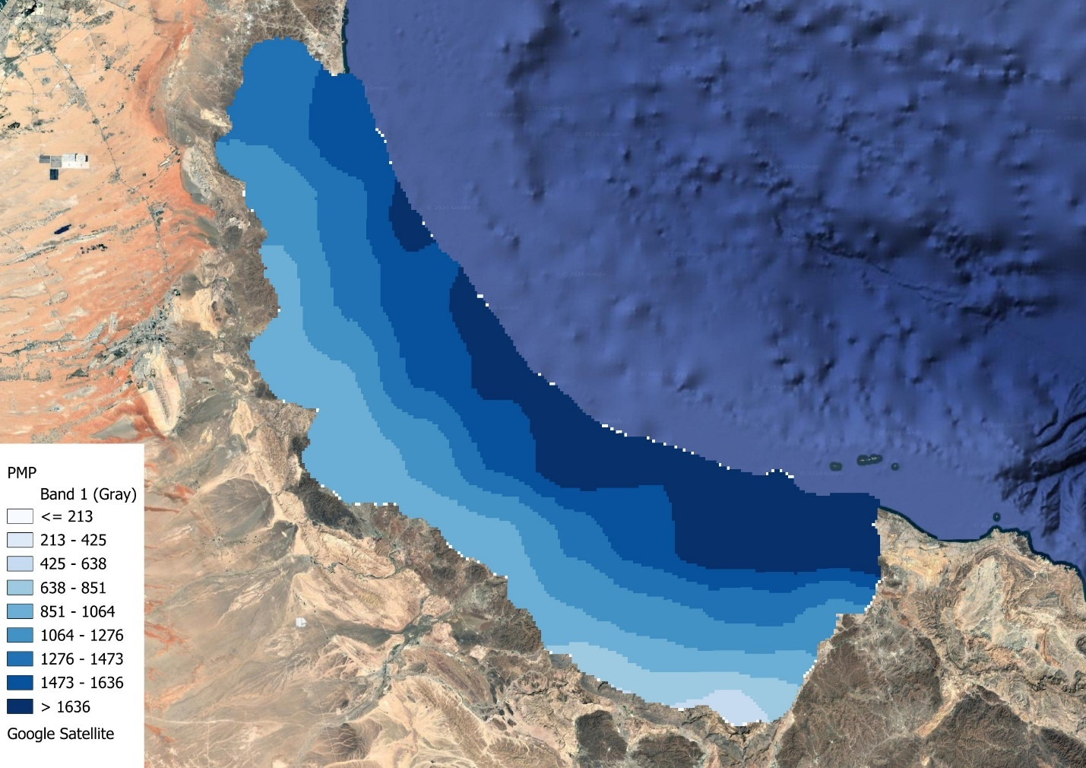
Figure 2-PMP grid

Figure 3- Rainfall Distribution Patterns
The Area Reduction Factor (ARF) accounts for the spatial variability of rainfall over a catchment. Point rainfall measurements tend to overestimate the average areal rainfall depth for large catchments, because intense storm cells rarely cover the entire catchment simultaneously. The ARF, a dimensionless factor ≤ 1, is applied to design point rainfall to obtain the spatially averaged areal rainfall. In this project, ARF values are derived from the nationwide hydrology study and applied to all catchments. This is especially significant for larger drainage areas in Block 6, where the ARF meaningfully reduces computed peak discharges.
Table 3- Area reduction factor (ARF)
Area (km²) | ARF
1 | 1
5 | 0.994
10 | 0.987
20 | 0.976
30 | 0.965
40 | 0.956
50 | 0.948
100 | 0.913
200 | 0.864
500 | 0.776
1000 | 0.694
2000 | 0.606
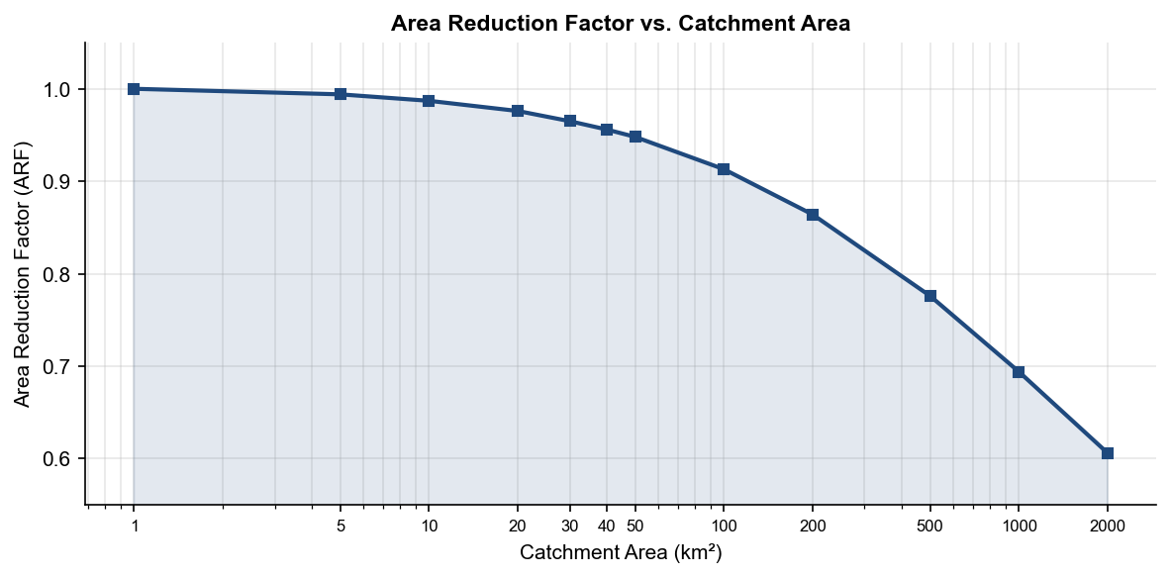
Figure 4 – Aea Reduction Factor Curve
The Curve Number (CN) grid was developed through the integration of two high-resolution global datasets: the ESA WorldCover 2020 (10 m) and the ISRIC SoilGrids (250 m). The ESA WorldCover product provides a refined classification of land use and land cover (LULC), allowing for a precise assessment of surface roughness and vegetation intercept. To account for subterranean influences on runoff, SoilGrids data was processed to determine Hydrologic Soil Groups (HSG) based on soil texture and drainage properties. The datasets were spatially aligned and combined via a standardized SCS (Soil Conservation Service) lookup table to generate a spatially distributed CN layer representative of the study area’s hydrologic response.
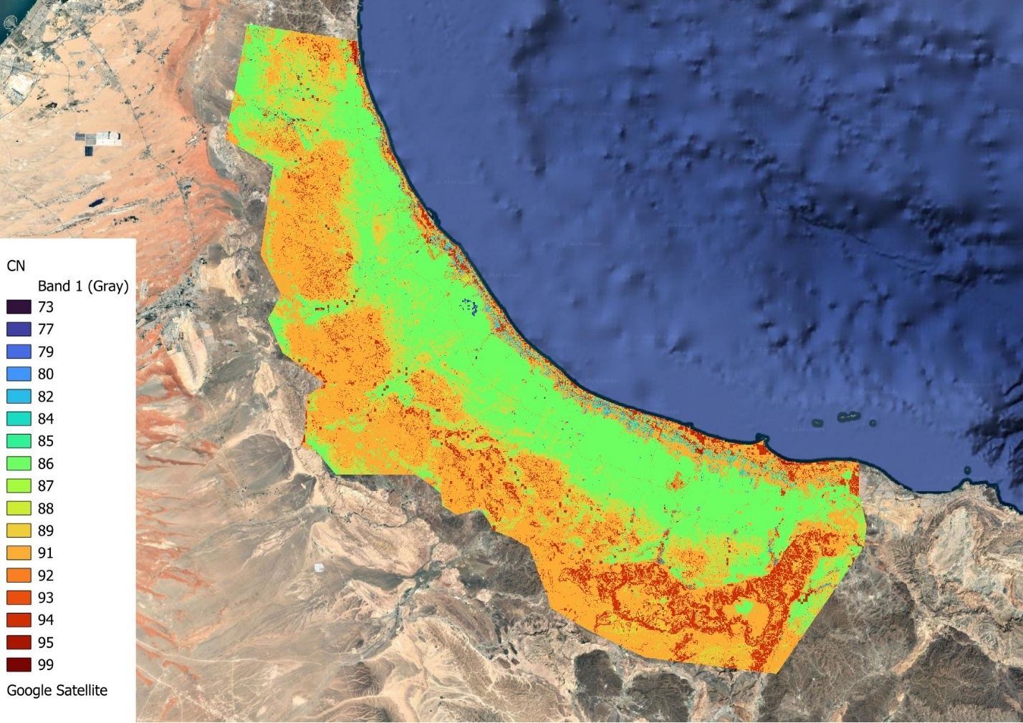
Figure 5- Curve Number grid

